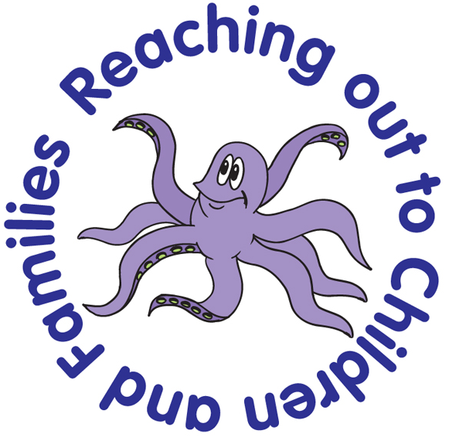
Octopus Children’s Daycare

SUN PROTECTION POLICY

EYFS key themes and commitments
A Unique Child | Positive Relationships | Enabling Environment | Learning and Development
1.4 health and Well-being | 2.2 Parents as Partners | 3.2 Supporting Every Child

Policy Statement
This policy outlines ways in which the Daycare can work towards minimising harmful effects from over-exposure to the sun’s ultraviolet rays. This is particularly important for young children as they have sensitive skin that can be easily damaged by the sun’s UV rays.
Children in the Daycare may also spend a lot of their time outdoors during the summer months; the Daycare places a high importance in protecting children in our care.
Procedures and Practices
To protect children in our care we:
- Ask parents/ carers to provide sun cream in a clearly named bottle. If we do not have sun cream provided by the parent/ carer, and not given permission to use the settings sun cream the child will have to remain in the shade during hot, sunny weather or wear suitable clothing with long sleeves and a sun hat provided by the setting. Staff will be able to apply sun cream when provided.
- Should parents/ carers not provide suncream they will be notified of the brand and factor available in the setting.
- It is the parent/carers responsibility to inform the setting if they do not want their child to use the settings suncream.
- Ensure children wear a suitable hat, preferable one with a wide brim and legionnaire style, with a large flap at the back. The Daycare has spare hats for children to borrow. Children who do not wear a hat will have to remain in the shade during hot, sunny weather.
- Encourage parents to dress children in t-shirts that cover shoulders, rather than strappy tops that exposes more skin to the sun.
- Have a shady area for outside play. Children will be encouraged to use it during hot, sunny weather, limiting the time children play in the sun when necessary. Activities will be planned for shady areas during hot, sunny weather.
- Encourage children to have an awareness of issues regarding the need to use sun cream, wear hats and appropriate clothes.
- Allow children to wear UV protective sunglasses.
- Practitioners encourage the children to have drinks throughout the day and water is available at all time to keep the children hydrated
- Children are able to bring in their own water bottles with their name on, these will be refilled when necessary.

At Octopus Children’s Daycare we acknowledge the importance of sun protection and want children to enjoy the sun safely.

Other policies to read in conjunction with this policy

- Octopus Children Centre Policies and Procedures
- Octopus Children’s Daycare Health and Safety Policy
- Octopus Children’s Daycare Health and Hygiene Policy
- Octopus Children’s Daycare General Data Protection Regulation Policy

This policy was adopted at a meeting of Octopus Children’s Daycare Management Committee

Signed by the Chairperson on behalf of the Management Committee

Date of signature

This Policy will be reviewed in December 2026

